Analysis of Game Reviews with a Natural Language Model

Daniel Shumway  Rochester Institute of Technology  drs7453@rit.edu | Jennifer Stanton  Rochester Institute of Technology  jas2715@rit.edu | Jascha Wilcox  Rochester Institute of Technology  jcw8139@rit.edu

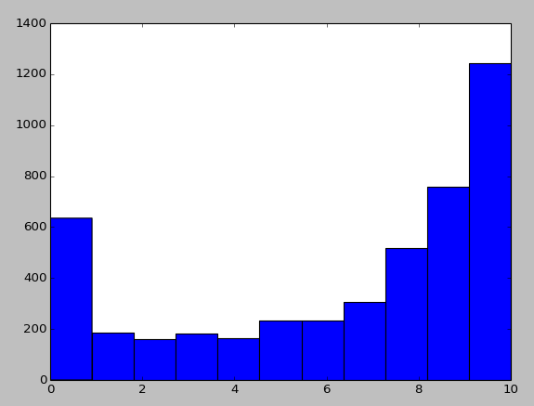

Abstract
The industry and culture of video games is full of opinions, ambiguities, and questions about what makes a game worth playing. Online resources of journalism such as IGN, and more casual user-based counterparts such as MetaCritic are abundant with written reviews of games. How do reviewers talk about games? What trends can be found within the language of game reviews? This article reports on the results of building a natural language model around analyzing the content of a review as compared to its associated numerical score. The model, once trained on a corpus, can then predict the assigned score of a review.
- Introduction
The goal of this experiment was to build a natural language model for the purposes of observing the language used in game review scores and to make an attempt at predicting the score assigned to a given review text.
- Data Set
A list of games released in 2013 was pulled from Wikipedia. The titles of these games were used to search the review site MetaCritic, via the Mashape API. A total of 26,619 reviews was used for the data set. The data set was split into a 22,000 reviews for training and 4,619 for test data.
Each MetaCritic review is paired with a score from 0 to 10 - as shown in Figure 1, the distribution of these reviews is highly uneven. This suggests to us that people tend to post reviews when they feel strongly about a game. A full 27% of the reviews gave a 10 score, which resulted in a rather aggressive baseline to improve upon.
Figure 1. Histogram of overall review score distribution.
- Experiment
In facilitating the goal of providing an examination into the features and quirks of review analyzation, a simple model was incorporated that could be easily replicated. This was preferred over an an in-depth study of which statistical methods yielded the better results.
  - Training the Data
The text of the training data reviews scores are first pre-processed by lowercasing, tokenizing, and removing all punctuation and stop words. Next, the program loops through each word found in the review and, as necessary, adds it to an internal dictionary. This dictionary tracks the number of times a word has been encountered overall, and how many of those encounters were matched with each review score (0-10).
In order to adjust for inherent biases in the training data (see above distribution of scores), the program subtracts the base likelihood of the review having a given score from each word. For example, if the program finds the word ‘good’ 30% of the time in 10 star reviews, the word would be assigned a likelihood of 3% (30-27). If it found the word ‘bad’ 10% of the time in a 10 star review, it would be assigned a likelihood of -17%. Unknown words are counted as 0 likelihood for all scores.
  - Testing the Data
For each review in the test set, the program uses the above collection of words and their likelihoods to calculate total likelihood sums by adding the likelihood of each word in the review. As an example, if the review consisted of the words, “I liked this game,” the total likelihoods of each score, 0-10 would be calculated by adding the likelihoods of “I,” “liked,” “this,” and “game” for each possible score.
- Results
  - Evaluation
The overall accuracy of the model predicting the exact review score is 20%, compared to the baseline of review score 10 at 27%. This is, unfortunately, a clear loss in overall accuracy. However, there are significant gains in other areas, namely the standard deviation of predictions vs. the correct scores, or put more simply, how far off of the correct answer the model tended to guess.
To measure this accuracy, a weighted scoring system was devised and was used alongside a more traditional calculation of standard deviation. Below is the standard deviation calculation, where pScore denotes the predicted score, and aScore denotes the actual score.

√(((pScore - aScore)² +(pScore - aScore)² + ... (pScoreN - aScoreN)2 ) / N)

A traditional calculation of accuracy can be said to weight correct guesses at 1.0 and incorrect guesses at 0.0, where the sum of all guesses is divided by the number of guesses.
The modified version used in this experiment weights “almost-correct” guesses for partial accuracy. While correct guesses are weighted as 1.0, partial credit is given for incorrect guesses as 1/(k+1) for k < 3, where k is the distance to the correct answer. For k >= 3, the weight is dropped to 0.0.
This partial-correctness is implemented to account for the large quantity of review scores that were assigned predictions close to their actual score. (For example, many scores were predicted as 8 but were actually 10; reviewers are likely to use similar words in nearby scores).
The formula for the weighted accuracy is calculated by taking the mean of all correctness values, where correctness is as follows:

Correctness = 1.0, for k=0
Correctness = 1/(k+1), for 0 < k < 3
Correctness = 0.0, for k >= 3

Using the weighted accuracy method above, there is a 4% improvement over the baseline (40% when only guessing 10, 44% when using our method). More demonstrable of improvements, however, is standard deviation. Under the baseline approach (guessing 10 for everything), the standard deviation of scores is 5.09, while the model reports a standard deviation of 2.85. This means that while the model may be exhibiting a loss in strict accuracy, its guesses are, on average, significantly closer than the baseline to the correct scores.
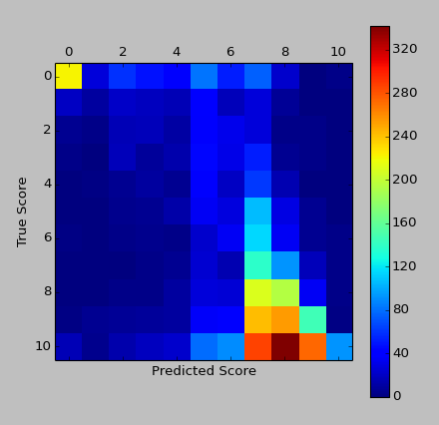
Figure 2. Heat map of predicted vs. actual game review scores.
  - Findings
While most predictions were at least relatively close to the actual score, some outliers were noted. Here is an example of a review that contains unusual text for a high review:

“When you start playing this game it shouts to you I AM YOUR MAIN GAME! Play me, you don't need any other.
Wizadry Online is harcore not because of posiblity of permadieing, oh yeah you die hard a lot, but you need even more for your champion to vanish for good, it hardcore because you need months to grind your strength and weeks to clear each dungeon without help of ppls who currently "life" in Kingdom of Dimento. I Currently played 800h adn will need another 3 weeks to perfect my final bulid of Master Thief of illfalo Port. If you search MMO game that you can sink in for hours, try WO. Currently US server is under PVP war and EU have less players but is place where PVE community resides, choose your patch.”
The actual score of the above review was 9, but the program guessed 2 due to the unusual language used. The frequent misspellings were likely also a large contribution to the error for being interpreted as unknown words.
Other review scores were predicted incorrectly when two likelihoods were extremely close to each other. Many of the same words seem to be used in scores 0 and 3, for example. Many reviews such as the following were either 0 or 3 and predicted as the opposite one:

“We knew this game was gonna suck, but it is just amazing how bad it is. It's like a pre-alpha game released to the public. Absolutely pathetic. The worst game I've ever played.”
The actual score was 0, but the predicted score was 3. The distribution of likelihoods was as follows:

0 likelyhood: 0.589995109795
1 likelyhood: 0.19163455179
2 likelyhood: 0.167050554404
3 likelyhood: 0.649143683616
4 likelyhood: 0.178947736191
5 likelyhood: 0.331964133915
6 likelyhood: 0.288930830331
7 likelyhood: -0.0901134297362
8 likelyhood: -0.1450141538
9 likelyhood: -0.724536898781
10 likelyhood: -1.43800211772

With the two likelihoods extremely close in numbers, the score was predicted incorrectly and likely occurred as such for a significant percentage of the other review scores.

- Discussion
One challenge that caused issues with the experiment was the large number of typographical errors found within the corpus. Though it would not be extremely difficult to attempt to correct some errors, doing so would not catch all of the misspellings. The misspelled words affect the word frequency counts by being counted as their misspelled version instead of the intended word.
A useful but ultimately unobtainable tool would have been to pull multiple reviews written by the same reviewer for the sake of eliminating person-by-person variation in the subjective nature of scoring the reviews. Extremely few (less than 100 in 26,000) reviewers had written more than four reviews.
- Future Work
The predictions of this model could be applied in multiple areas of game reviews. Some reviews, such as those found on Steam, are solely text-based. Predicting a probable score for score-less reviews could be used for sorting or searching data, or for calculating how the Steam community generally ranks certain games.
The predictions could also be used to identify fake reviews, such as ones that say positive things about the game yet assign a low score, or vice-versa.
A study was performed in 2008 to identify common themes occurring in the discourse of game reviews. The researchers found that there were nine major themes ranging from ideas both internally within the game and externally in the outer world, such as the video games industry (Zagal, Ladd, and Johnson, 2008). Future work could be performed to apply a discourse-based approach to a game review analysis model such as the one described here.
References
José P. Zagal, Amanda Ladd, and Terris Johnson. 2008. Characterizing and Understanding Game Reviews.

